Hi,
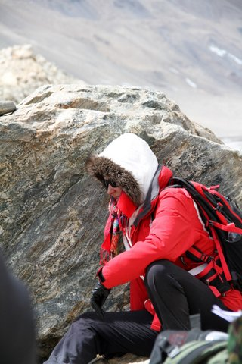
For those of you who don’t know me, I’m a Grade 2 Homeroom Teacher. I am also one out of 22 teachers who have been selected to climb Kilimanjaro to raise money for The Varkey Foundation which has designed a low-cost teacher training program that will address the issue of teacher quality in developing countries. I am absolutely delighted to have been chosen as I have always wanted to climb this majestic mountain and to be able to raise money for education in Africa.
To try to raise as much money as possible some of the Kili team have come up with the amazing idea of a cycle challenge with the incentive being those who enter the competition will be entered into a draw to win a brand new bike from the ‘Ride Bike Shop.’
As a keen sports woman I will be one of the Kili crew undertaking the cycle challenge riding for several hours during the event.
I hope lots of you will enter the cycle challenge and remember you can enter as many times as you like to increase your chances of winning a fabulous new bike.
Many thanks
Miss Jo.

